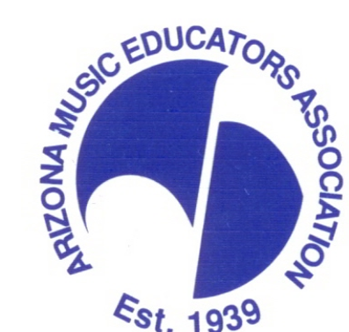 2020 Arizona Junior High All-State Orchestra Festival

January 3, 2020

Dear All-State Orchestra Member and Families:
Congratulations! You have been chosen to represent your school in the 2020 Junior High All-State Orchestra. The Junior High All-State Orchestra is comprised of 100 outstanding student musicians from schools across the state of Arizona.

- The Junior High All-State Festival will be held at: Perry High School
1919 E Queen Creek Rd Gilbert, AZ 85297
- The date will be: Saturday, March 21, 2020. The festival begins at 8:00 am, and the concert will begin at 4:00 pm.

- All music must be learned before you arrive. Please ask your private music teacher or school
music teacher for help.
4. Bring your music and at least one sharpened pencil with you.
5. Chair auditions will be held the morning of the festival, and will consist of passages from the festival repertoire, and major scales (C, G, D, A, F, and Bb at M.M. = 120 in quarter notes).
6. Respect the campus and property. It is a privilege to use this facility for our Festival. Do not bring candy, gum, or drinks into the building (water is okay).
7. Snack items will be available for purchase but plan on having a good nutritious breakfast before you come if possible. You may also bring snacks from home.
8. Please wear concert clothing for the all-day rehearsal, striving to wear clothing that is primarily black and white colors. Examples of concert dress could be-
Option 1: dresses, blouses (no low cut tops), skirts (hemmed below the knee), nice shoes
Option 2: dress pants, ties, nice shirts, nice shoes
You may wear comfortable shoes and change them before the concert if necessary, but there will not be time to change into your concert clothes. Bring hair combs and brushes. Please do not bring curling/flat irons or other electrical appliances. A sweater, sweatshirt or light jacket is recommended for wear during rehearsals.
9. All-State T-shirts and Plaques will be available for purchase the day of the festival.
10. A CD recording of the evening concert will be available for purchase and will be e-mailed to you. CD recording order forms will be available at the festival site. Parents, please do not record the concert with any recording devices in the auditorium because of copyright infringement.
11. Tickets may be purchased at the door for $5.00 for each adult and children over 5 years of age, cash only. No complimentary tickets are being provided this year.
12. Participants must be present for the entire time of the rehearsal and sectionals. Attendance will be taken at every rehearsal and sectional.

Here is the tentative schedule:
7:30am Meet your director at Perry High School
7:45am Registration – Participants will have their director check-in for them, receive lunch tickets, schedule, name tags, etc. Proceed to rehearsal rooms
8:00am Chair placement auditions and sectional rehearsals
11:45am Lunch
12:30pm Full Rehearsal
3:30pm Break before the concert
4:00pm Concert on stage

Again, congratulations on being selected to participate in the Junior High All-State Orchestra. We are looking forward to a wonderful performance of Arizona’s finest junior high string musicians!

Sincerely,
Shana Roberts
AMEA Junior High All-State Orchestra Chair

